**Social Media Sentiment Analysis Report**

Intern Name: Mohammad Adnan Shoeb Akhtar

Company: Brainwave Matrix Solutions

Task 2 – Data Science/Data Analytics Internship

Title: Social Media Sentiment Analysis Using NLP, Excel and Power BI

Date: May 31, 2025

### ****1. Introduction**** This report presents insights derived from social media data related to trending tech hashtags such as #AI, #CloudComputing, #DataScience, #MachineLearning, and #Python. Using NLP sentiment classification and the VADER model, we analyzed the tone of discussions across platforms like Twitter, Instagram, and Reddit. ****Data Sources****

**Platforms Analyzed**: Instagram, Twitter, Reddit  
  
**Analyze 600 social media posts.**

classify content as **Positive**, **Neutral**, or **Negative** using:

Predefined sentiment labels

VADER sentiment scores.  
  
  
**Visualize key patterns and trends across:**

Hashtags

Platforms

Time

Engagement metrics (likes and shares)

**Hashtags Monitored**:

#AI

#CloudComputing

#DataScience

#MachineLearning

#Python  
  
**Total likes and shares**

Total Likes: 141K

Total Shares: 58K

#### ****2. Sentiment Overview**** ****Manual Sentiment Analysis (from Dashboard 1)****:

**Positive Sentiment:** 209 posts

**Neutral Sentiment:** 203 posts

**Negative Sentiment:** 188 posts

· **Top Hashtags with Positive Sentiment:**

#Python and #MachineLearning showed higher positive sentiment.

· **Platform Sentiment Distribution:**

Instagram, Reddit, and Twitter each contributed roughly equally across sentiment types.

Positive sentiment is slightly more represented on Instagram and Twitter.

· **Likes and Shares:**

**Likes:** 141K

**Shares:** 58k

**Trend Over Time:**

Positive and Neutral sentiments occur more frequently and consistently throughout the year, while Negative spikes are less frequent.  
  
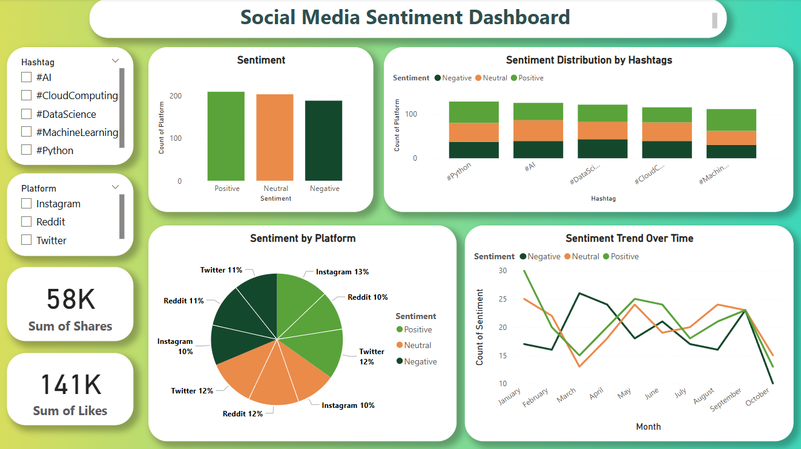

# ****VADER Sentiment Analysis (from Dashboard 2):****

· **Positive Sentiment:** 482 posts

· **Neutral Sentiment:** 118 posts

· **Negative Sentiment:** Not classified in this version.

· **Hashtag Performance:**

All five hashtags (e.g., #AI, #Python) show significantly more positive sentiment compared to neutral.

· **Platform Sentiment Distribution:**

**Instagram:** 27%

**Reddit:** 28%

**Twitter:** 26%

Positive sentiment dominates across all platforms, especially on Instagram and Reddit.

Trend Over Time:

A steady stream of positive sentiment, with frequent neutral events but no negative classification.

### 

### ****3. Platform Sentiment Analysis****

### ****#Manual Sentiment:****

Each platform (Instagram, Twitter, Reddit) has a nearly even distribution across all three sentiment categories.

Twitter and Reddit slightly edge out Instagram in share.  
  
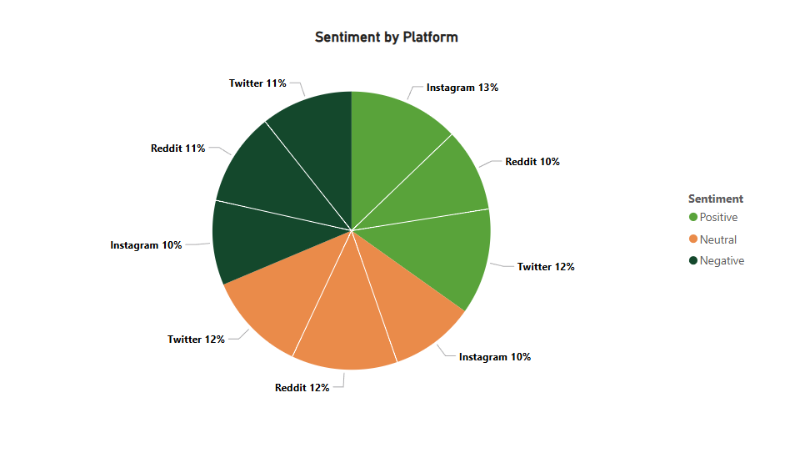  
  
**Visualization**: Pie chart showing sentiment share by platform

### ****#VADER Sentiment:****

**Reddit (28%)** and **Instagram (27%)** dominate positive sentiment volume.

Twitter shows less activity in comparison (26% positive).  
  
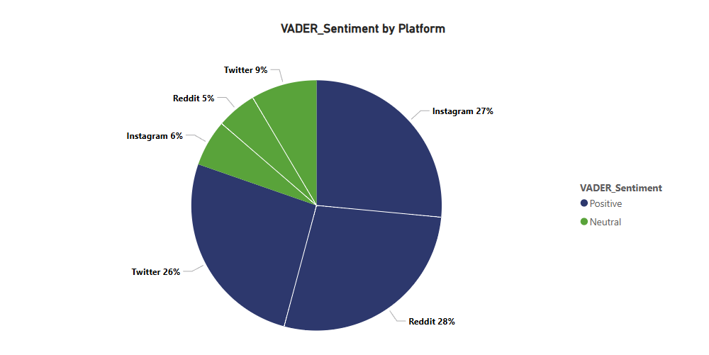  
  
**Visualization**: Pie chart showing sentiment share by platform

**4. Sentiment by Hashtag**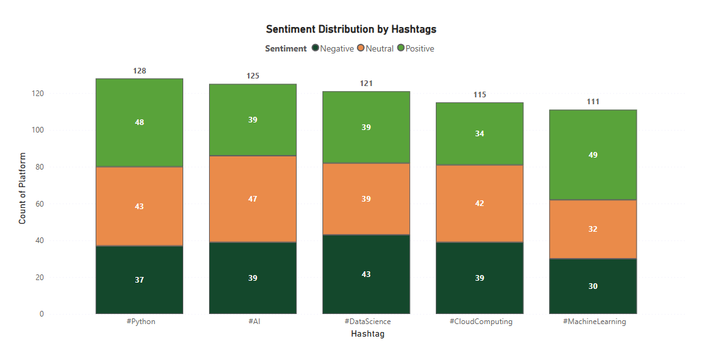  
  
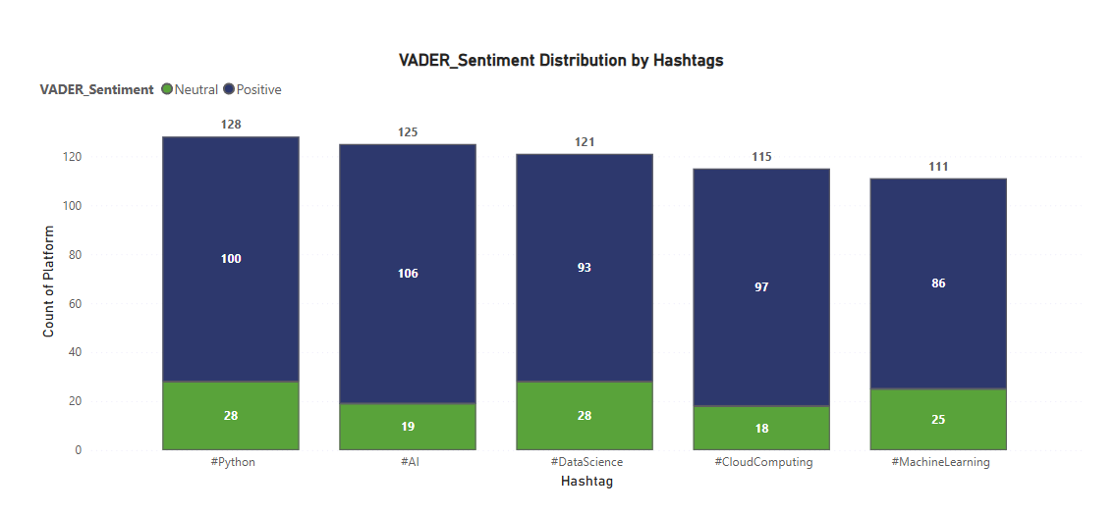  
  
**Insights**:

**#MachineLearning** and **#Python** show the **highest positive sentiment** in both analyses.

**#DataScience** consistently shows **lower sentiment polarity**, with a higher share of negative/neutral responses in the manual method.

### ****5. Sentiment Trend Over Time****

# Sentiment activity over months (March–October 2024) reveals:

**Visualization**: Line and bar charts tracking sentiment counts over time

### Fluctuations in public opinion, with peaks in May and July 2. VADER results show a higher frequency of positive sentiment peaks. ****6. Engagement Metrics****

**Total Likes**: 141K

**Total Shares**: 58k

## Positive sentiment correlates with higher likes and shares, showing a strong link between tone and engagement. ****7. Methodology****

### ****a. Data Preprocessing****

Lowercased text

Removed punctuation, URLs, and emojis

Removed stopwords using NLTK

### ****b. Sentiment Classification****

**Manual Labels**: Based on a predefined column in the dataset

**VADER Analysis**: Used compound score to classify:  
  
Positive: ≥ 0.05

Neutral: Between -0.05 and 0.05

Negative: ≤ -0.05

### ****c. Visualization in Power BI****

1. KPIs: Total Likes, Shares

2. Bar Charts: Sentiment distribution, hashtag performance

3. Pie Charts: Platform-wise sentiment breakdown

4. Line Charts: Sentiment trend over time

## ****4. Tools Used 1.**** Python (Pandas, VADER, NLTK) – Data Cleaning and Sentiment Analysis

**2. Power BI** – Dashboard Development

**3. Google Colab** – Notebook Execution

**4. Microsoft Word** – Report Preparation

### ****Conclusion**** 1. Overall Sentiment is positive, but differs by analysis method: 2. VADER detects higher positivity than manual classification.

### 3. #MachineLearning and #Python are highly favored.

### 4. Platform-wise, Reddit and Instagram contribute the most to positive sentiment, while Twitter appears more neutral.

5. Spikes in engagement correlate with major dates or trends